Capstone Project Weekly Progress Report
Semester | Fall-2024 Semester 3rd
Course Code | AML-3406
Section | Section 1
Project Title | Car Damage Detection
Group Name | Group B
Student names/Student IDs | Sakshi (C0908000)  Bansil Patel (C0912873)  Harsh Mohile (C0912872)  Meet Patel (C0910378) – TL  Rachit Bhatt (C0902810)
Reporting Week | Week 4
Faculty Supervisor | William Pourmajidi

Grade the level of collaboration from different aspects between team members:
(use: good, medium, below expectation)
Sakshi | Bansil Patel | Harsh Mohile | Meet Patel | Rachit Bhatt
Good | Good | Good | Good | Good

Tasks outlined in the previous Weekly Progress Report for this reporting week at the individual level and group level
  - Individual tasks (each team member)
Sakshi: Learning VS Code + Learning GitHub.
Bansil Patel & Meet Patel: Learning VS Code + Exploring Dataset.
Harsh Mohile & Rachit Bhatt: Learning VS Code + Creating Branches for automation and deployment, and over Git Management.
2.2 Your team’s tasks
- Adapting VS-Code as IDE for development and version control.
- GitHub Management.
- Exploring Dataset.

Progress made in Reporting Week at an individual level and group level
  - Individual progress
Sakshi: Understood basics of VS-Code Extensions and GitHub.
Bansil Patel & Meet Patel: Applying NN and Model Evaluation through Summary.
Harsh Mohile: Worked on the quality-assurance branch for applying test automation.
Rachit Bhatt: Worked on the production branch for launching the tested piece of solution to the cloud.
  - Your team’s progress
- GitHub Management for Deployment and Test-Automation.
- Applying initial NN function and testing the results on the sample data.

The areas/tasks you could not make progress and/or complete as scheduled or the difficulties encountered in this reporting week at individual level and group level.
  - Individual project blockers
Sakshi: N/A
Bansil Patel: N/A
Harsh Mohile: N/A
Meet Patel: N/A
Rachit Bhatt: N/A
  - Your team’s project blockers
- Since the tasks of this scrum were quite smooth, luckily; there were no blockers in this week.

Tasks to be completed in next week at individual level and group level
  - Individual tasks
Sakshi: Research on CI/CD Pipelining for ML-Ops.
Bansil Patel & Meet Patel: Applying various models initially on the dataset.
Harsh Mohile & Rachit Bhatt: Research on Docker for Deployment.
  - Your team’s tasks
- Exploring and understanding the dataset.
- Research on Docker for Deployment.

Include the tasks from your sprint planning (Github/Zenhub) for the present period.
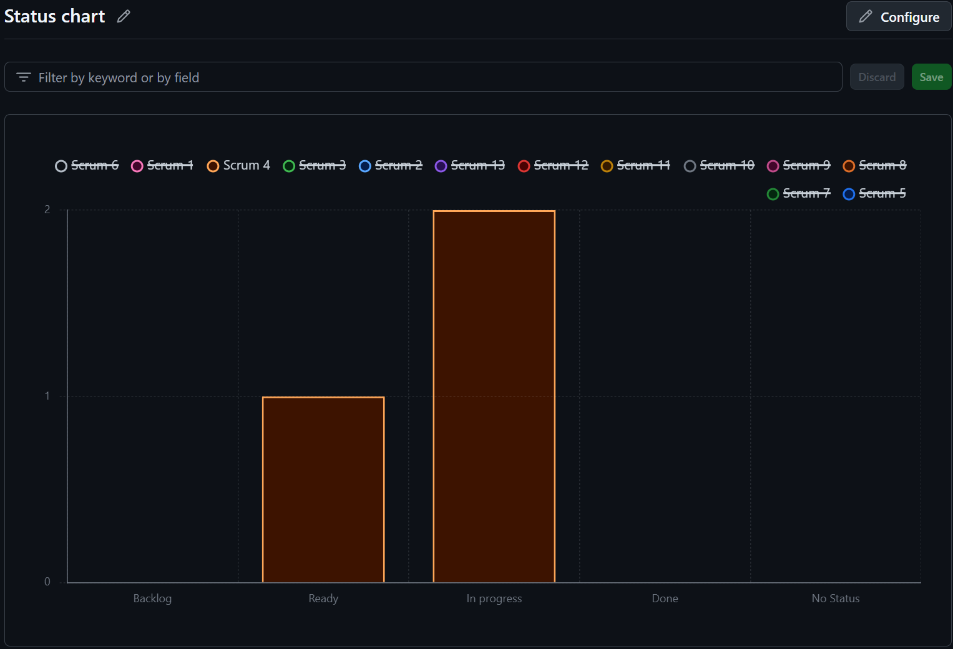
Figure 1: Status Chart of GitHub Issues in Milestone

Include charts/graphs (e.g., burn down charts) from your project management tool (Github/Zenhub) that shows your progress for the period of this report.
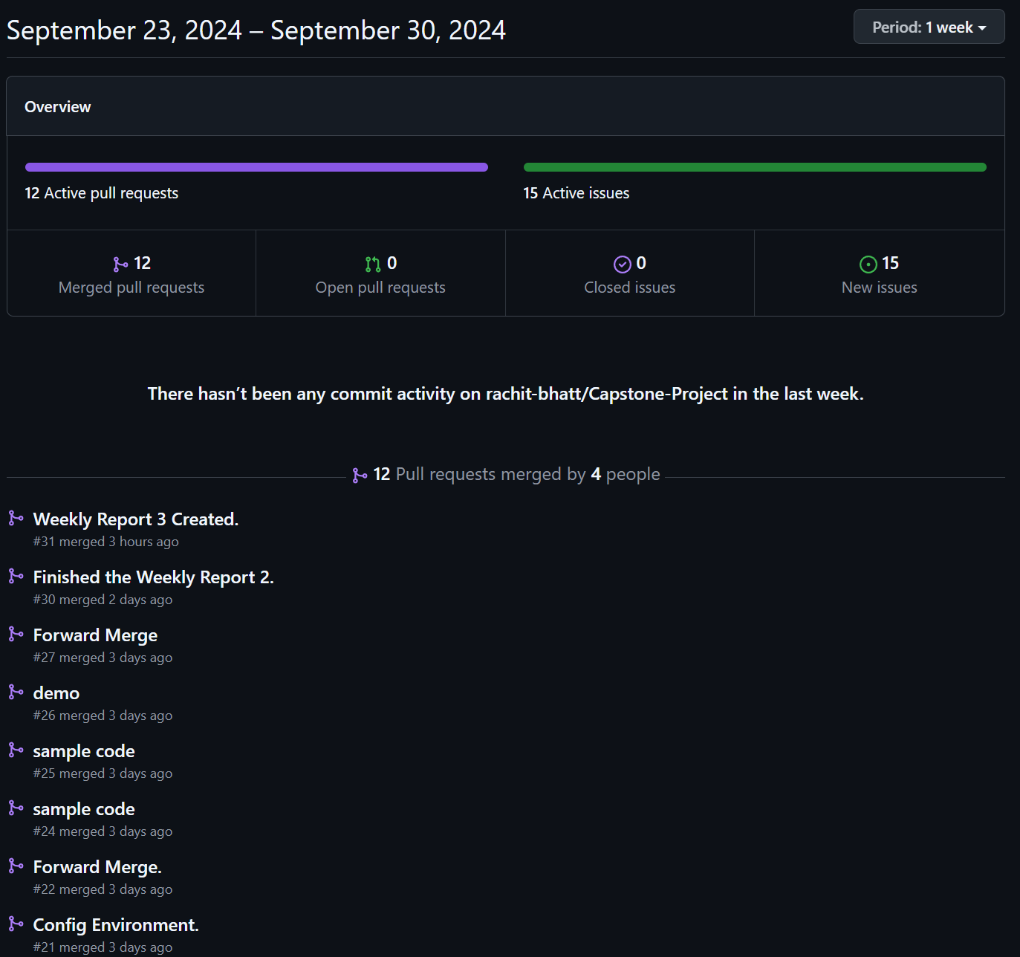
Figure 2: Contributors in the Week

Include a note and address to your project Github with list of codes uploaded/updated on Github in this reporting week.
GitHub: https://www.github.com/rachit-bhatt/Capstone-Project
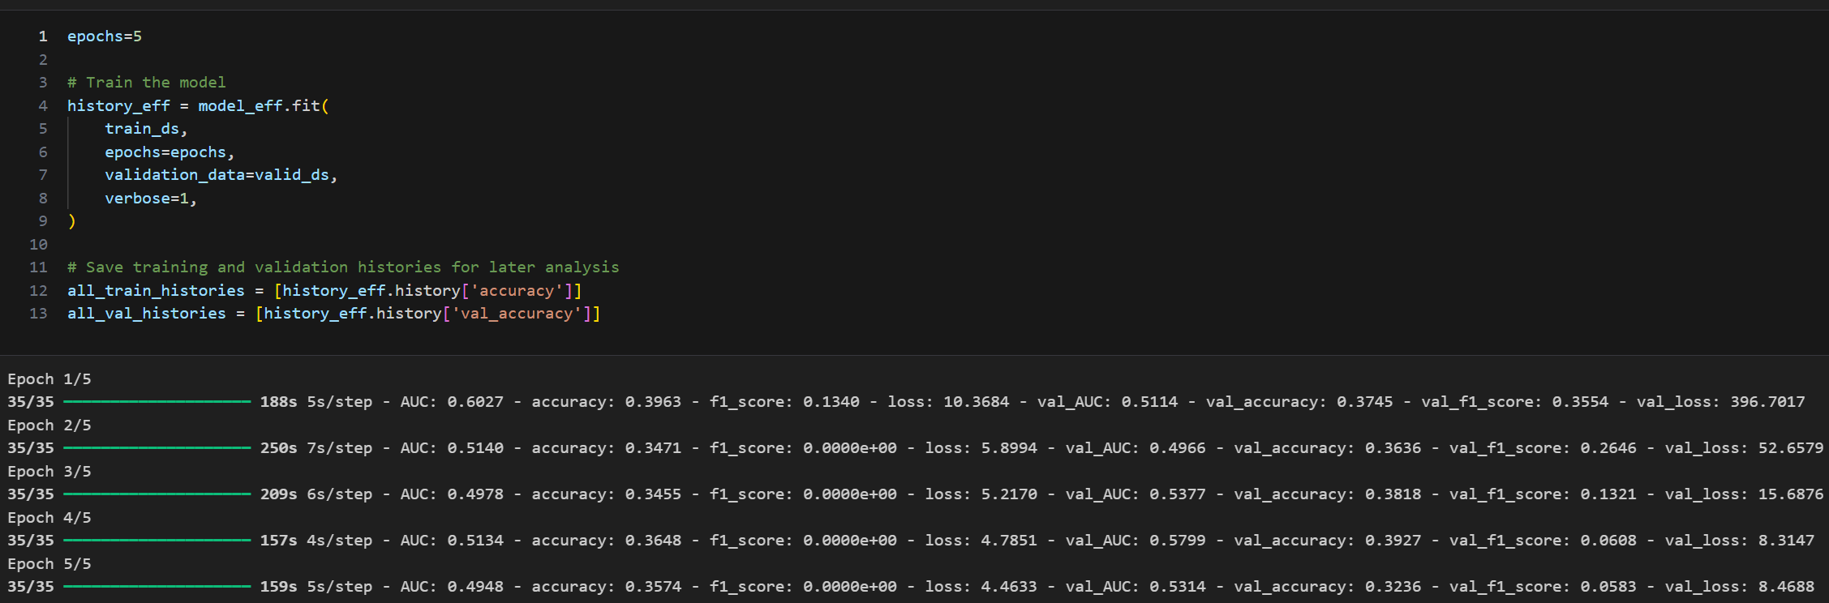
Figure 3: Applying NN on a Sample Dataset
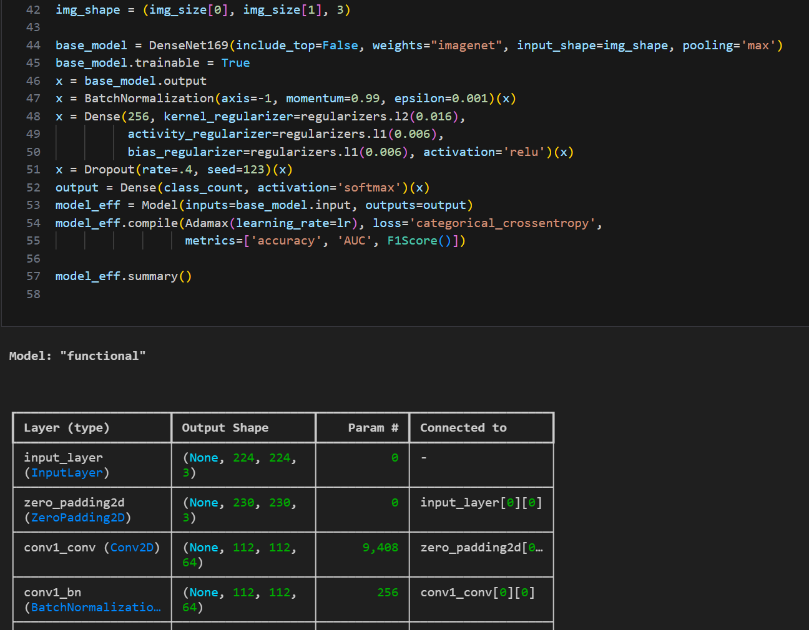
Figure 4: Model Evaluation Summary

